An Amazing Pumpkin Pie (aka Gram’s Drunkin’ Pumpkin Pie)

Recipe as written by Jean Stolt) in the cookbook she made for her daughter, Jennie.

Makes two 9” pies

2 c. brown sugar
¾ c. butter
1 c. PET (evaporated) milk
4 eggs, beaten
4 c. pumpkin
1 tsp. each cinnamon, mace & nutmeg
½ c. whiskey (bourbon) or to taste – (plus a ½ c. for Gramma - WHOOPIE!!!)
Cheat – 2 frozen deep-dish pie shells, thawed

Cream together butter and sugar. Add beaten eggs and spices, PET milk & pumpkin and mix well. Add bourbon and mix well. Pour into pie shells and bake at 400 º F for 50 minutes.

This recipe was given to your great-grandmother Canepa by Mrs. T. G. Breant in 1898. Grandma was the head housekeeper at Selma Hall * outside of Festus, MO.

* Selma Hall, or "Kennett's Castle", is located four miles south of Festus and one mile east of Highway 61. Selma Hall, its formal name, is a house patterned after North Italian Renaissance country houses. It was designed by George I. Barnett, English-trained St. Louis architect, for Ferdinand Kennett, Mississippi River steamboat operator. Probably the finest antebellum home in Missouri, it was built in 1854, at a cost of $125,000, and was called Kennett's Castle by river men who have persisted in calling the mansion this name. Its gray limestone walls and square, four-story tower crown a succession of terraces, which to the east overhang the Mississippi River, and to the west overlook landscaped grounds which include a formal garden. The house was gutted by fire on March 13, 1939, during the ownership of William O. Schock of St. Louis, but has been restored by the firm of Nagel and Dunn to approximately its original appearance.
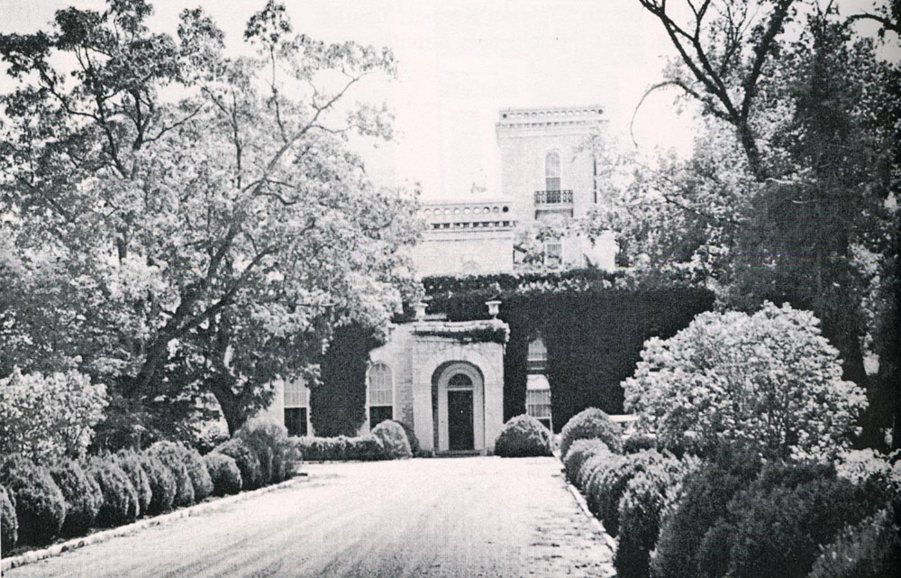
Selma Hall was built on land given Mrs. Kennett (formerly Julia Deadrick) by her grandfather, John Smith "T", an expert marksman in duels, and one of the largest lead-mine operators. The castle was occupied by the Kennett family until the Civil War time, when the castle was frequently fired upon from boats on the Mississippi. The family fled to St. Louis for safety. Tradition says that Union forces stabled their horses in the stone mansion, and this magnificent and historic structure, like many others of the antebellum period, was left in ruin. The home was eventually restored to its original impressive elegance. Selma Hall and its imported furnishings were indicative of the wealth and tastes of two aristocratic families - the Smith "T" and Kennett families - both prominent in early land development, lead mining, and other business activities of early Missouri.
from Historic Sites of Jefferson County, Missouri (Eschbach, Walter L.)

